SHAHEENA KHALID
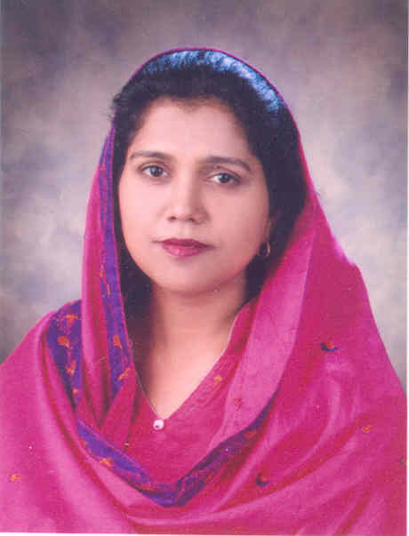

MARIA HOMES R-10 ST - 9 SECTOR 14-B
NORTH NAZIMABAD TOWN
Tel (Res): 021-6922512 Mobile 0333-2256188 & 0333-3013063
Email: shaheena_khalid@hotmail.com

Having come to know through reliable sources that some posts are lying vacant under your kind control. I want to offer my services for the above post. My Particulars are as under:

Personal Profile
Name Shaheena Khalid
Husband ’s Name Khalid Mahmood
Date of Birth 06/01/1970
Nationality Pakistani
Religion Islam
Marital Status Married

Educational Qualification
MBA Banking & Finance Greenwhich University (G.P.A 3.45)
M.A (Islamic Studies) Karachi University (First Division)
B. Ed Indus College of Higher Education (G.P.A. 3.42)
B. Com Karachi University (2nd Division)
F. Sc (Pre-Engineering) (Govt. College for Women Nazimabad) (First Division)
Matric Science (A Grade)
Languages Fluent spoken and written English, Urdu
Computer Skills Acquired expertise in different courses of computers & MS office etc.

Teaching Experience

- Presently teaching in Bahria Foundation College Block ‘J ‘North Nazimabad Campus.

- Two years experience as Lecturer of English, Business English, Report Writing, Financial Accounting, Introduction to business in Government Polytechnic Institute for women.

Interest

Reading, cooking, poetry, computers

References
Will be furnished upon Request

